Neural Network and Deep Learning

TOPIC

Building an Image classifier using the Sequential API

Task 1: Importing the Libraries necessary to perform the MLP on the dataset.
Dataset: MNIST Fashion dataset. (70,000 grayscale images of 28x28 pixels, with 10 Classes)
Import all the required libraries – We have imported all the required libraries and checked the version of the TensorFlow.
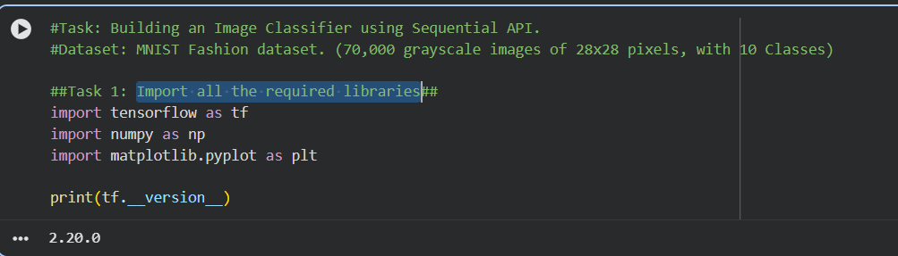

Task 2: Successfully load dataset
2.1: Use Keras API to load dataset.
We have successfully loaded the “fashion mnist” dataset. Then performed the the training set (the data the model will use to learn) consists of the X_train_full and Y_train_full arrays. The model is tested against the X_test and y_test arrays. (series of tests)

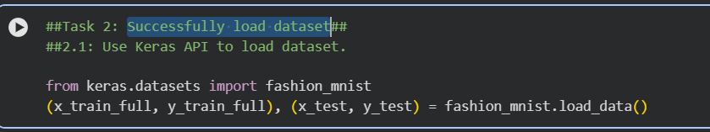

2.2: Class names (labels) are not included with the dataset; we will store them to use
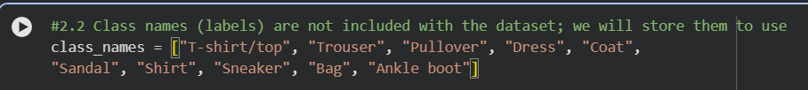

Task 3 Exploring the dataset & We are splitting the dataset into Train and Test
3.1 Checking the shape and size of the dataset and also splitting the dataset into train and test.
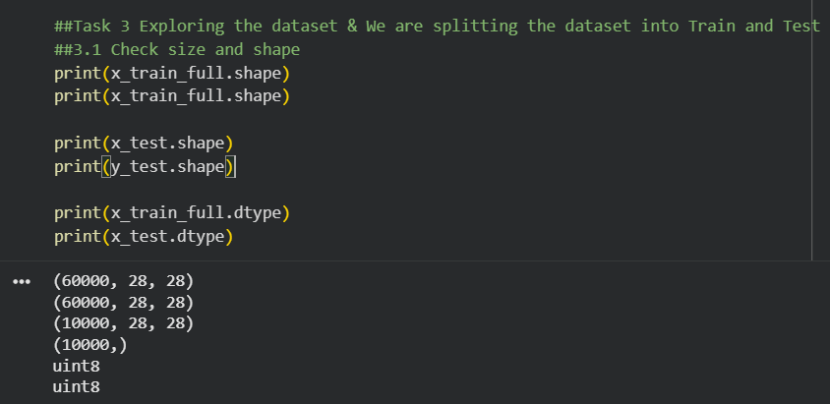
3.2 Scaling the pixel value 0-255 to the value 0 & 1.
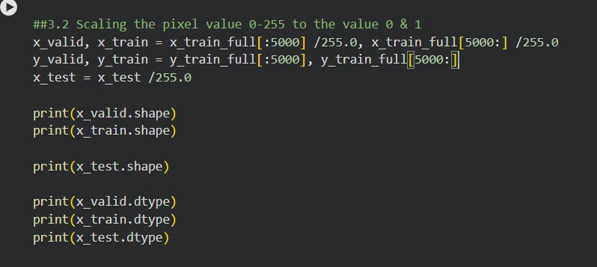
3.3 Display first 25 images and its names from the training set and from we used range till 25 to classify with names. We worked around “plt” in this section to get the good plot.
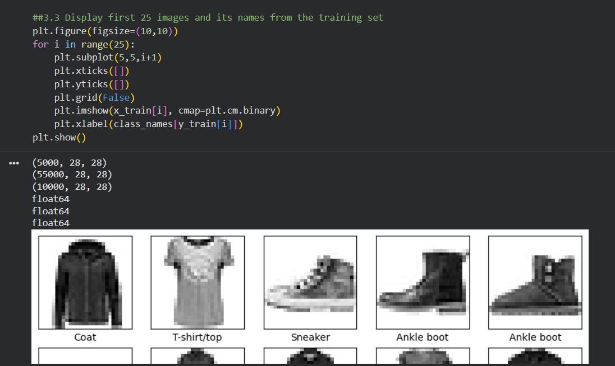

Task 4 BUILDING NEURAL NETWORKS
4.1: Use Keras sequential API to build your model (MLP with 2 hidden layers). In this we have used the Rectified Linear Unit and SoftMax function to get the output from the complex data.
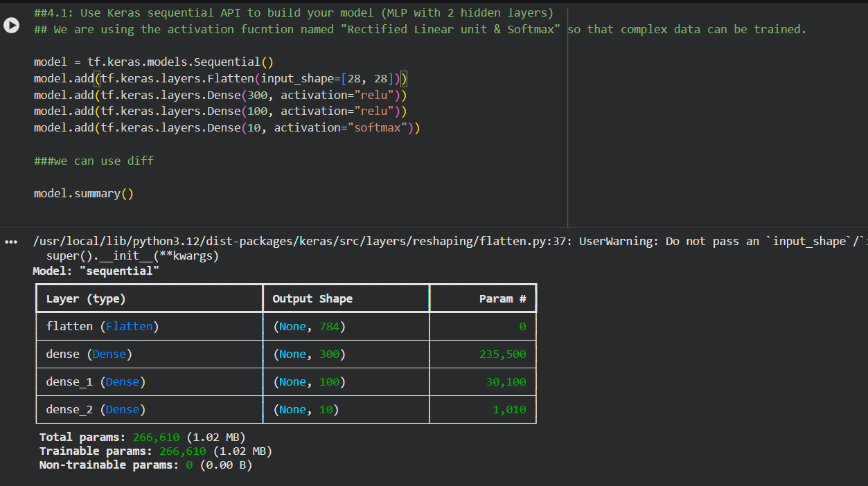

Task 5 Compiling and Training the Model
5.1 Tweak learned parameters (learning rate, optimizers, loss functions etc.). We are using the cross-entropy loss function and also going with epoch 50. In the initial we haven’t got the proper accuracy due to the server issue we trained it multiple times.

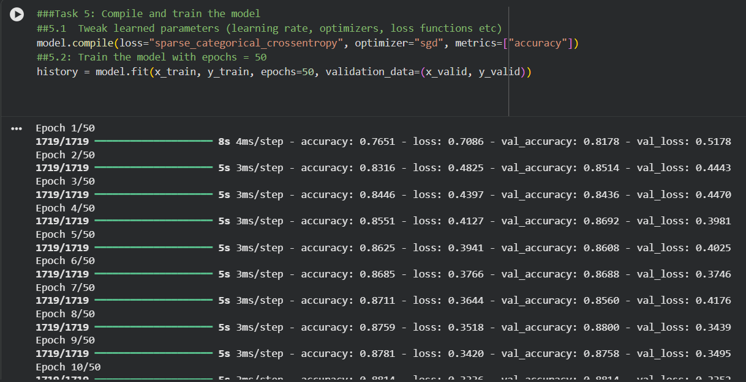

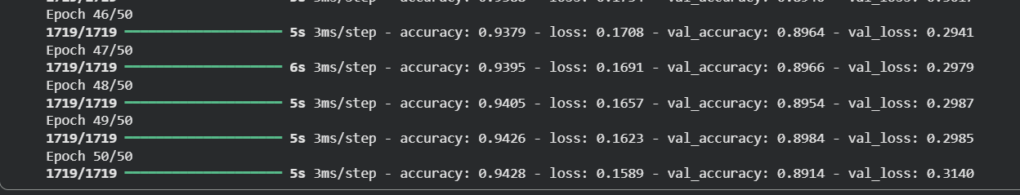

Task 6 Plotting the curve
After training the data we can see the curve accuracy (blueline) is moving towards 0.7 to 1. We can also see the yellow line at the bottom declining towards the 0.2 (loss). We have imported the Pandas library.
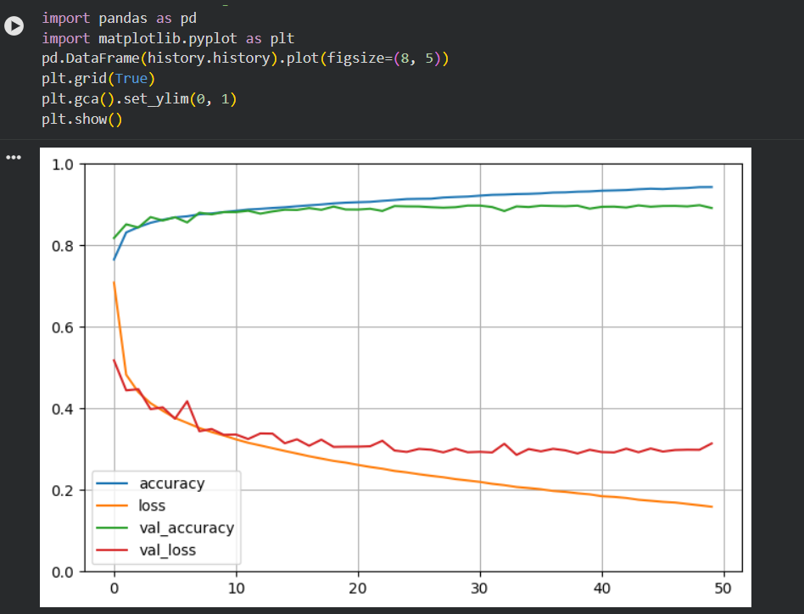

Task 7 Evaluating the test accuracy.
We calculated the test accuracy with the X_test & Y_test. We got 0.8809
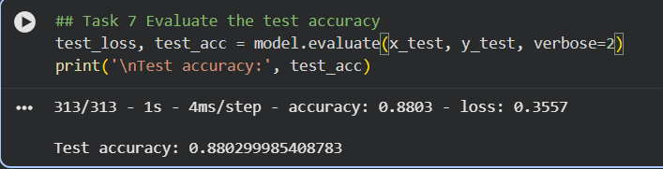

Task 8 Making Prediction on the Test dataset
8.1 Predicting the output – Defining everything into the Probability model with the help of Keras and Tensorflow.

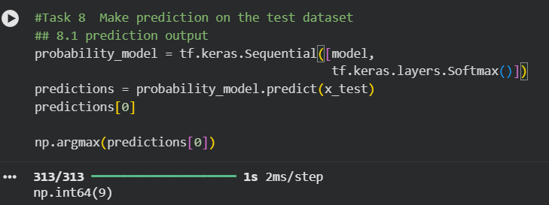

8.2 Examine with test label (y_test), shows the classification is correct

